AQ Skills – Focussing on Rebuttal
Students will be able to:

- Apply relevant evaluation strategies for the AQ response.

- Demonstrate evaluative balance convincingly and in more nuanced manner for the AQ response.

Some Useful Reminders on AQ
- Possible phrasing of AQs from Specimen Paper
The reading passages cover a range of views about the collection and use of personal data.
- How far do you agree that online personal data collection brings about more benefits than harm? [Cost-benefit Comparative]
- How far do you agree that concerns about how our personal data is collected and used are unfounded? [Concerns – Extent]
- How far do you agree or disagree that the collection of personal data could be used to benefit everyone in the society? [Benefit – Stakeholders]

- AQ Assessment Rubrics
Criterion | Band 4 (10-12m) | Band 3 (7-9m) | Band 2 (4-6m) | Band 1 (1-3m)
Requirements | Sustained focus on the requirements of the question; balanced response | Good focus on the requirements of the question with some evidence of balance | Some focus on elements of the question with an attempt at balance | Limited focus on the question with little or no balance
Explanation | Cogent answer with very good understanding of the terms and issues raised by the passages | Good understanding of the terms and issues raised by the passages | Some understanding of the terms and issues raised by the passages | Limited degree of understanding with a higher incidence of misinterpretation
Evaluation | Convincing evaluation, making judgements, and developing arguments to logical conclusions; elaboration and support through personal insight and experience, with apt illustration | Attempted evaluation but not always convincing; mostly valid illustration | Superficial analysis; limited development of ideas and few illustrations | Summary or restatement of the text with a few undeveloped and assertive comments; little or no illustration

- AQ Structure/Flow
Option 1: Agree “to a large extent” [WFH is good]
*both claims [OF THE SAME SIDE]
*can be from the single or different passage(s). [because Passage 3 can be use to support Passage 1 or 2]
Option 1A: Fuller Version  Intro: [SV] Stand + SG feature(s) – e.g. WFH is good  Para 1:  - Chose 1st claim to support your stand [WFH good]  - Explain applicability to SG  - 2 EGs + Insight  - OPV [WFH bad]  - Rebuttal  - Concluding sentence  Para 2:  - Chose 2nd claim to support your stand [WFH good]  - Explain applicability to SG  - 2 EGs + Insight  - OPV [WFH bad]  - Rebuttal  - Concluding sentence  Conclusion: Restate stand + memorable closure | Option 1B: Shorter Version  Intro: [SV] Stand + SG feature(s) e.g. WFH is good  Para 1:  - Chose 1st claim to support your stand [WFH good]  - Explain applicability to SG  - 2 EGs + Insight  - OPV [WFH bad]  - Rebuttal  - Concluding sentence  Para 2:  - Chose 2nd claim to support your stand [WFH good]  - Explain applicability to SG  - 2 EGs + Insight  - Use deeper SG feature to strengthen EV [support]  Conclusion: Restate stand + memorable closure
Option 2: Agree with Passage 1 + Agree with Passage 2 + EV-Stand-Conclusion [Cambridge Specimen Example]
Both claims must be from 2 different passages of OPPOSING views
Para 1:
- Chose 1st claim [Agree with Passage 1 idea [2024 WFH is good] is applicable to SG]]
- Explain applicability to SG with SG features
- 2 EGs + Insight
- EV: Use deeper SG features/EV lens to strengthen 1st claim
- Concluding sentence

Para 2:
- Chose 2nd claim [Agree with Passage 2 idea [2024 WFH is bad] is applicable to SG]]
- Explain applicability to SG with SG features
- 2 EGs + Insight
- EV: Raise some challenges to this claim to weaken 2nd claim
- Concluding sentence

Conclusion:
- **State stand [weighing - more good than bad to SG]**
- Apply EV strategies to demonstrate how you arrive your stand [ie use EV lens, deeper SG features]
- Memorable closure

Option 3: Debate Approach [OPV – Rebuttal – SV] WFH is good
*both claims [OF THE SAME SIDE] can be from the single or different passage(s). [because Passage 3 can be used to support Passage 1 or 2]
Option 1: Full version | Option 2: Shorter version
Intro: My Stand [SV] + SG feature(s) – Eg. WFH is good.  Para 1:  - Choose 1st claim that challenges [OPV] your stand [ie WFH is bad]  - Explain OPV’s applicability to SG  - 1 Eg to support OPV  - Rebuttal  - Present my stand [SV] - [ie WFH is good]  - 1 Eg to support SV  - Use of deeper SG features  - Concluding sentence  Para 2:  - Chose 2nd claim that challenges [OPV] your stand [ie WFH is bad]  - Explain OPV’s applicability to SG  - 1 Eg to support OPV  - Rebuttal  - Present my stand [SV] - [ie WFH is good]  - 1 Eg to support SV  - Use of deeper SG features  - Concluding sentence  Conclusion: Restate stand + memorable closure | Intro: My Stand [SV] + SG feature(s) – Eg. WFH is good.  Para 1:  - Choose 1st claim that challenges [OPV] your stand [ie WFH is bad]  - Explain OPV’s applicability to SG  - 1 Eg to support OPV  - Rebuttal  - Present my stand [SV] - [ie WFH is good]  - 1 Eg to support SV  - Use of deeper SG features  - Concluding sentence  Para 2:  - Chose 2nd claim that supports [SV] your stand [ie WFH is good]  - Explain applicability to SG  - 1 Eg to support SV  - Use of deeper SG features  - Concluding sentence  Conclusion: Restate stand + memorable closure

Section 1: What are the key EV strategies? A Recap
Key EV strategies include:
- Context
- Alternative interpretations or points of view [using EV lens]
- Gaps in the assumptions
- Acknowledging its validity but suggesting an alternative approach
- Refuting the opposing view, showing that it (the opposing view) is concerned with something else that is not that relevant to the question
- Refuting the opposing view, showing that some other factor is the crucial factor (Be careful not to change the subject matter!)
For this comprehension set, we will be applying the following 3 more commonly used EV strategies in AQ:
- Context
Details | Sample Phrases / Stems
- Applicability of the issue depending on:  - Manifestation in your society/world  - Causes in your society/world  - Consequences in your society/world  - Degree of impact [extent, severity …] in your society/world  - Outlook on the issue in your society/world  - Strengths and weaknesses of the points/ideas  - implications and consequences of the issue on different groups in society:  - Demographic profile  - Socio-economic profile  - Cultural diversity  - Political ideology  - Historical and geographical reality | - In my society, however X differs from (the author’s context)  - X, has less of an impact on my society because of …  - My society’s <feature> has led to a different response towards X  - X is largely inapplicable today because…  - X is becoming less relevant as we examine future trends…  - Young/old, male/female, millennial/baby-boomer  - Rich/middle-class/ poor  - Race; religion; local-born/foreigners  - Liberals/conservatives; moderates/extremists

- Alternative interpretations or points of view [using EV lens]
Details | Sample Phrases / Stems
Consider alternative interpretations based on your experience or your society. Consider:  Lens 1: Needs of the majority vs minority OR Individual needs vs. greater good of society  Lens 2: Long term vs. short term gains or consequences  Lens 3: Actual vs. Potential  Lens 4: Pragmatic vs. idealistic considerations  Lens 5: Cost-benefit analysis  Lens 6: A means to an end or an end in itself  Lens 7: Change vs. continuity | - When we compare the costs of X to the benefit, we can clearly see…  - While in the short term there are… there are long term benefits…  - While the majority of citizens… a minority of people…  - Idealists would argue X, yet pragmatically speaking…  - One may question whether X is a means to an end or an end in itself  - While X may harm the individual, it ultimately brings about a greater good for society.  - One may wonder if changes the X brings are beneficial or whether things should have continued as status quo.

- Gaps in the assumptions
Details | Sample Phrases / Stems
Point out gaps in the assumptions which are not present in your experience or in your society:  - Conditions assumed to be the norm  - Attributes assumed to be the norm  - Unstated premise on which the argument is based | - It is a fallacy to believe that X is a norm  - The author’s point wrongly assumes that…  - This argument fails to recognise…  - This argument however rests on a false/shaky assumption that….  - The author has over generalised the situation

Section 2: Applying the EV Strategies and Crafting Evaluation in AQ
Application Question:
9. The reading passages cover a range of views about whether comedy should or should not be free to offend.
How far do you agree or disagree that comedy’s freedom to offend should be restricted?
Support your answer with reference to:
- the ideas and opinions from at least one of the reading passages
- examples drawn from your own experience and that of your society.

What are we discussing? | Comedy: a genre of literature, performance, or media that  - aims to entertain and provoke laughter  - by highlighting the humorous aspects of human behaviour, social situations, or language.  - At its core, comedy exposes the absurdities and contradictions of life,  - often using wit, irony, satire, exaggeration, and parody.
How are we discussing it? | Whether or not comedy’s freedom to offend should be restricted (reasons/justifications for & against are required)  Purpose of comedy:  - To entertain and provide joy  - To explore difficult or taboo topics  - To critique society and institutions  - To challenge power and authority  Concerns:  - Offensiveness and sensitivity  - Misinterpretation of humour  - Reinforcement of stereotypes
What is the context/scope of our discussion? | Whether or not comedy’s freedom to offend should be restricted in Singapore’s society:  - 10% - labelling of SG features  - 90% - historical underpinnings, geographical constraints, social make-up/organisation/demographics, dominant cultural norms and beliefs, political norms, current developing trends, national vision/goals/aspirations

When applying EV strategies, you MUST consider the following:
- Have I evaluated the text ideas by taking into account the features of Singapore?
- To achieve balance, have I highlighted opposing perspectives or acknowledge shortcomings of my view and rebut them?
- How can I strengthen my view?
- Which evaluation strategies I am going to use?
- How am I going to phrase my evaluation convincingly and with more nuanced?
- How can I arrive at a sound/valid judgemental conclusion so as to answer the AQ?

Stand: In the context of Singapore, comedy’s freedom to offend should be restricted.

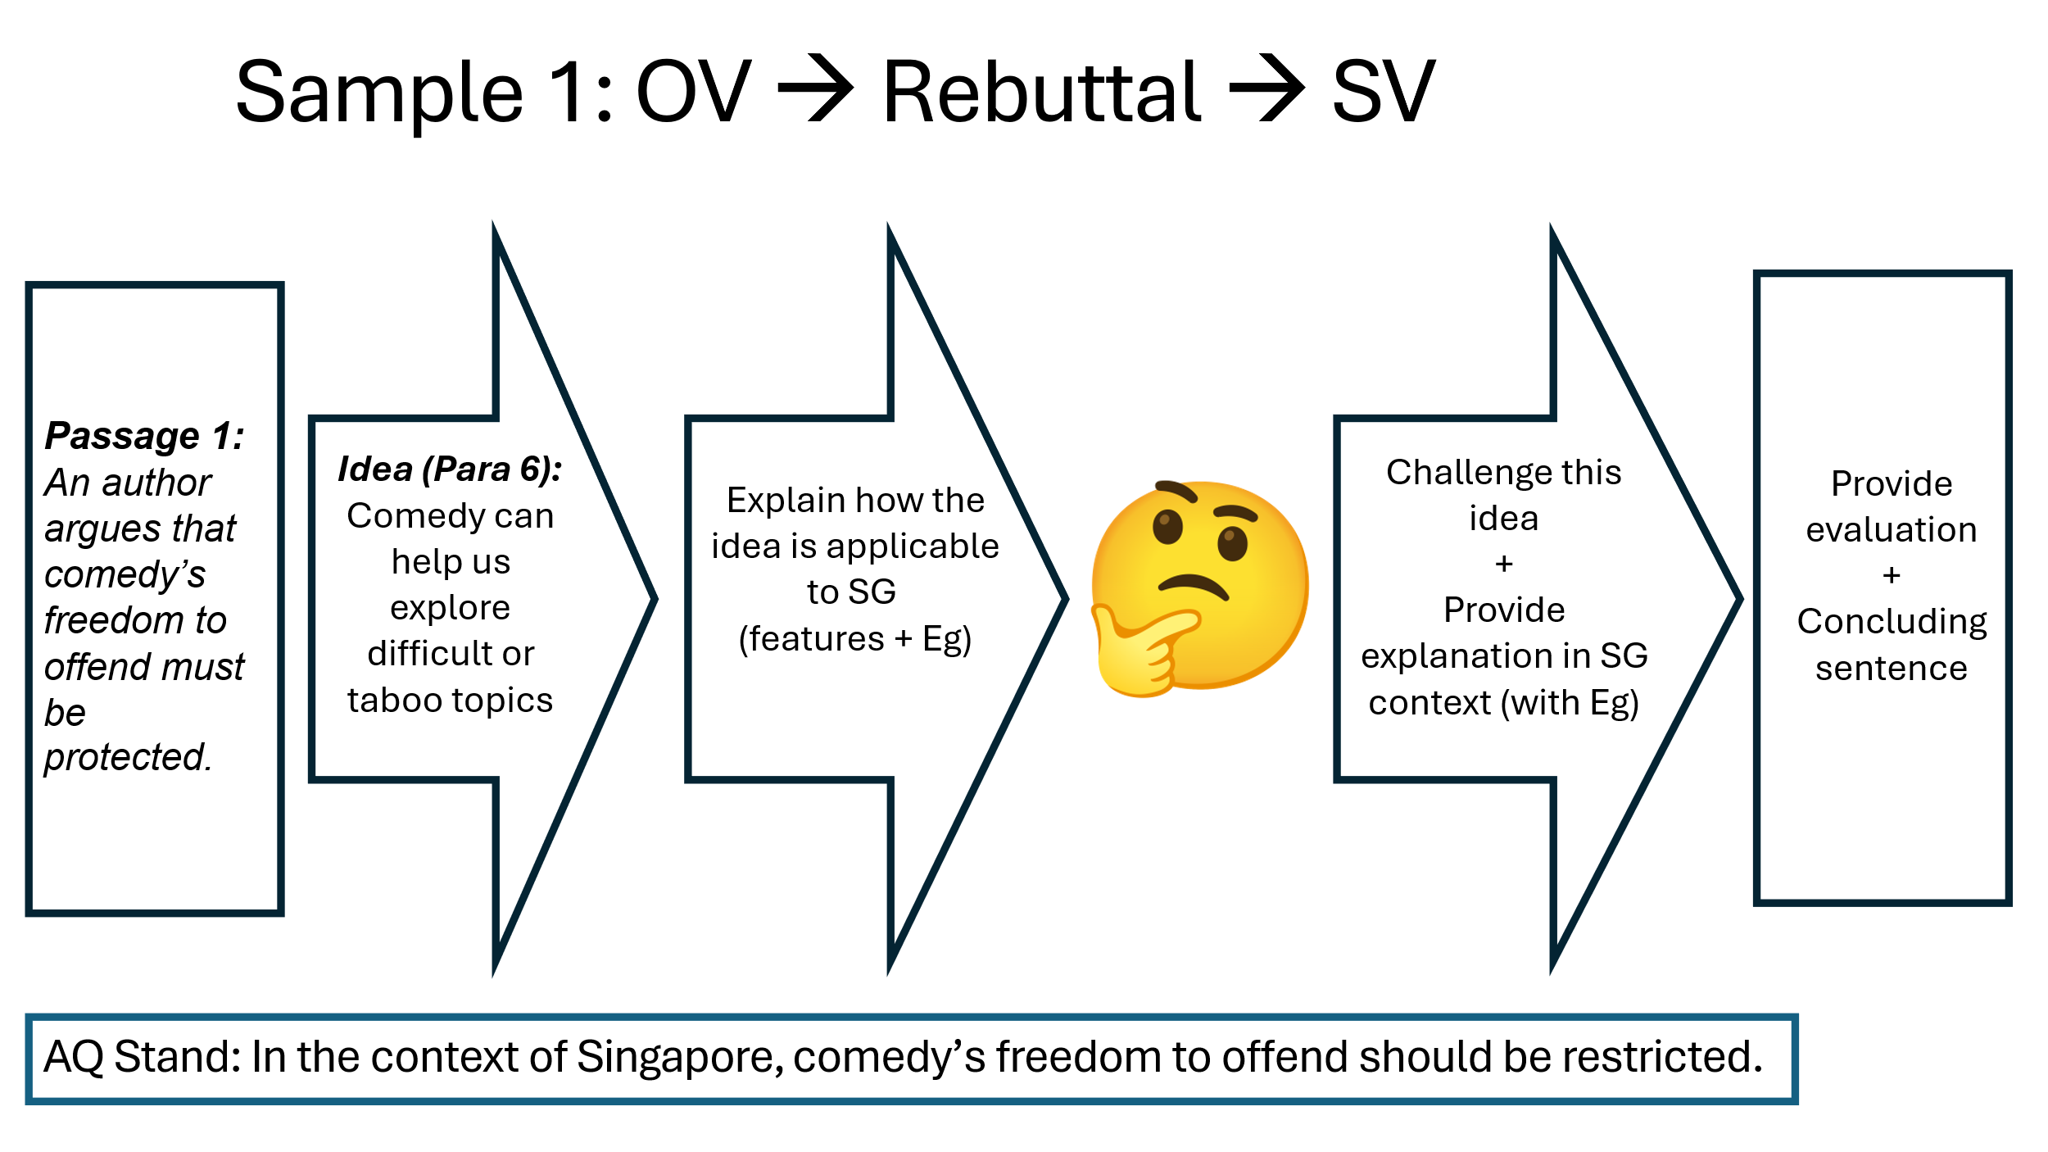

[OPV] Claim/Idea | In Passage 1 paragraph 6, the author claims that “Comedy is the excavation of darkness within the safety of laughter; we laugh because we see the shadow of truth in that darkness and the laughter keeps the shadow tamed.”
Explanation of OPV (to clarify claim, if necessary) | Indeed, comedy serves as a distinctive means of engaging with sensitive or difficult issues by cloaking them in humour, allowing audiences to confront uncomfortable truths without feeling personally targeted or emotionally burdened. By uncovering laughter within the darker aspects of life, such as injustice, suffering or taboo matters, comedy provides a release of tension and encourages reflection, rendering such challenging topics more approachable and at times more palatable for society.
Example for OPV | An example is the satirical online series The Noose, which aired on Singapore’s Mediacorp Channel 5. The show parodied local news broadcasts and featured exaggerated characters that reflected various ethnic, social, and bureaucratic stereotypes. Through humour, The Noose addressed issues such as government inefficiency, housing concerns, and national identity, allowing viewers to engage with these often-sensitive topics in a light-hearted way.
Rebuttal +  [SV] Stand + Explanation using SG Features | While I acknowledge that comedy can serve a constructive role in Singaporean society, its freedom to offend must be carefully restricted, as even well-intentioned humour may be misinterpreted, with audiences focusing on the offensive elements rather than the underlying critique. This poses a challenge to the country’s historically fragile social fabric. Singapore’s experience in the 1960s, marked by violent racial riots and strained relations with Malaysia following separation, demonstrated how provocative speech and unrestrained expression can swiftly escalate into social unrest and diplomatic tension. In light of this troubled past, the government has adopted a cautious stance toward satire, particularly in mainstream media. Comedy sitcoms like The Noose were deliberately moderated to remain within regulatory boundaries, reflecting a broader effort to ensure that humour does not inflame ethnic sensitivities or destabilise regional relations.
Example for SV | A pertinent example of an unregulated comedy performance is the backlash faced by Jocelyn Chia in 2023, a Singapore-born comedian who made an offhand joke about the disappearance of Malaysia Airlines Flight MH370 during a performance in New York. While Chia may have intended the joke as a satirical take on the historical rivalry between Singapore and Malaysia, the joke was widely perceived as callous and offensive, given the tragic loss of life. The incident angered both Malaysians and Singaporeans, who viewed it as a tasteless exploitation of tragedy for comedic effect. The joke even sparked diplomatic responses, with Singapore’s Foreign Minister publicly condemning the remarks and clarifying that Chia no longer represented the country, with the intent of containing any further fallout that may affect the bilateral relations across the strait.
Possible Phrasing of Evaluation using EV Lens | [EV Strategy: EV lens – Cost-benefit analysis]: This incident highlights that even when comedians aim to provoke thought or expose uncomfortable truths, humour can be counterproductive if poorly received. In this case, any potential benefit of encouraging reflection on national identity or regional rivalry was overshadowed by the emotional harm caused. The backlash demonstrates that laughter, rather than prompting critical engagement, can sometimes deepen offence and inflame public sentiment. In a region where aviation tragedies remain painful and deeply personal, such jokes are more likely to alienate than enlighten.  OR  [EV Strategy: EV lens – Intended vs Unintended consequences] The gap between intention and impact was stark. Chia may have sought to satirise political tensions between Singapore and Malaysia, but her delivery and choice of subject matter resulted in widespread outrage. Rather than fostering dialogue, the joke was interpreted as mocking a national tragedy, leading to calls for official accountability and even legal action. This reveals how, especially in culturally sensitive contexts like Southeast Asia, the audience’s interpretation can sharply diverge from the comedian’s original purpose, producing outcomes that undermine rather than support social critique.  OR  [EV Strategy: EV lens – Idealism vs Reality] - This case challenges the idealistic belief that comedy should be boundlessly free or that audiences will always engage with it in good faith. In reality, humour that trivialises grief, suffering, or national trauma risks normalising insensitivity rather than encouraging meaningful conversation. In a multicultural and diplomatically cautious society like Singapore, such jokes not only damage bilateral relations but also erode the credibility of comedy as a space for responsible discourse. The Chia incident exemplifies the need to balance creative expression with cultural sensitivity and social responsibility.
Concluding lines: | In conclusion, while comedy holds the power to provoke thought and challenge societal norms, it must be exercised with care, especially in a culturally diverse and politically sensitive context like Singapore.

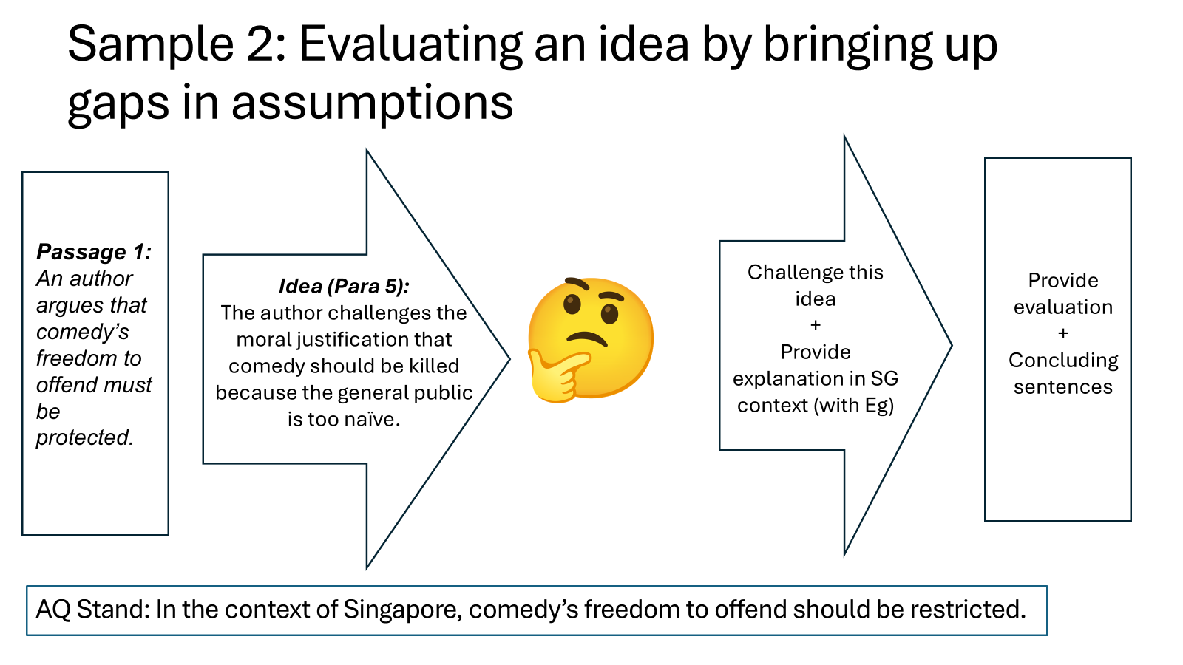

[OPV] Claim/Idea | In Passage 1 paragraph 5, the author claims that “at the root of the choice to kill comedy is a fear that the world is full of mindless straw-people who may launch into immoral havoc upon hearing a dangerous joke, which uncovers one’s arrogance in believing that one is uniquely morally superior.”
[OPV] Explanation (to clarify claim, if necessary) | Those who seek to censor or cancel comedy often view themselves as morally superior and more discerning than the general public. They believe that audiences are naïve or easily influenced, and that provocative jokes may trigger inappropriate behaviour, potentially leading to social unrest. When this line of reasoning is applied to Singapore, it implies that the average citizen is perceived as intellectually incapable of distinguishing between humour and genuine malice, thereby legitimising restrictions on comedy.
Rebuttal +  [SV] Stand + EV + Explanation using SG features | [EV - Gap in Assumption] While I agree that comedy’s freedom to offend should be restricted, attributing this solely to the idea that some individuals are more impressionable than others oversimplifies the rationale behind such regulation. In Singapore, these restrictions are not a reflection of public naivety but are deeply rooted in the nation’s historical and social realities. Although Singaporeans are generally well-educated, they still live in a society where comedy intersects with highly sensitive issues of race, religion, and collective memory. These issues have been shaped by past traumas and the enduring legacy of multicultural tensions. Regulation, therefore, functions less as a form of censorship rooted in elitism and more as a pragmatic safeguard to maintain social cohesion.
Example for SV | A telling example is the 2019 incident involving YouTuber Preeti Nair and her brother Subhas Nair, who released a satirical rap video titled K. Muthusamy in response to an e-payments advertisement that featured “brownface.” Although the video aimed to call out racial insensitivity, it swiftly met with public backlash and official censure for allegedly inciting hostility between communities. The controversy also reignited a national debate, spanning from official media platforms to social media and even being discussed at length at parliamentary sessions, on the boundaries of humour in a diverse society and whether satire can truly be separated from its social consequences and polarizing the Singaporean society into Singaporeans who believe in the necessity of stricter regulations and those who prefer greater freedom for expression.
Evaluation | [EV – Deeper SG Context] The debacle was not hypothetical. It has its roots in Singapore’s painful experience of the 1960s racial riots and its enduring emphasis on racial harmony highlight how even well-intentioned jokes can trigger deep anxieties in a society where ethnic sensitivities remain ingrained. Assuming that education alone equips Singaporeans to engage maturely with offensive humour overlooks these historical wounds and the government’s consistent prioritisation of unity. Comedians must therefore navigate a delicate balance between critique and provocation in a context where satire can quickly cross the line into social disruption.
Concluding lines: | Ultimately, the regulation of comedy in Singapore is not about moral superiority or distrust in public discernment. Rather, it reflects a realistic understanding of the potential for humour to destabilise fragile intergroup relations in a multicultural society. In such a context, the freedom to offend must be weighed carefully against the collective right to live in a respectful and inclusive environment.

Samples 3(a), (b), and (c): Evaluative balance to Achieve More Nuance
Acknowledge exceptions/variation in terms of:
- Context
- Stakeholders
- Time
- Type / way / method
Variation in… | Still, it is important to consider how the offensiveness of comedy is often perceived differently depending on who is making the joke. When a comedian from the targeted group makes a self-referential joke, it is more likely to be seen as introspective or playful rather than malicious. Fakkah Fuzz’s bit about “Uncle Abu” – a Malay man who offers stereotypically laid-back, even illogical answers to serious questions – resonates well with Malay audiences because it comes from an insider speaking with affection and cultural familiarity. In contrast, similar jokes made by the Chinese majority may be viewed as ‘punching down’ and reinforcing negative stereotypes. This suggests that any regulation of offensive humour should consider not just the content, but the positionality of the speaker, in order to avoid suppressing valid intra-community critique or humour.

Variation in… | While it is important to restrict offensive comedy in general, the manner in which jokes are delivered can significantly affect how offensive they seem. Satirical or ironic delivery that “punches up” – criticising those in power or societal hypocrisies – tends to be received with greater tolerance and even admiration. Jinx Yeo’s routine, for example, pokes fun at the irony of the Singapore government offering graffiti courses while criminalising actual graffiti, highlighting systemic contradictions rather than attacking individuals. When humour is used as a mirror to reflect uncomfortable truths rather than to ridicule the powerless, audiences are more likely to laugh with rather than feel targeted by the joke. This underscores the need for regulation to be discerning – not all offensive content is harmful, especially if it serves a critical or reflective purpose.

Variation in… | With that said, it is important to acknowledge that as Singaporeans become more educated and mature as a citizenry, our tolerance and appetite for offensive jokes have grown. Jokes once considered unacceptable—such as Kumar’s routines featuring crude racial stereotypes and risqué humour about sexuality—are now often embraced as bold and authentic rather than harmful. The fact that an unapologetically offensive comedian like Kumar continues to sell out shows year after year despite high ticket prices is a testament to comedy’s growing demand and acceptance in Singapore’s increasingly mature society. This suggests that even as restrictions remain vital today (as argued above), the restrictions may be gradually relaxed as society grows more resilient and open-minded.

Infusing the idea of variation into the stand to make it more nuanced:
From:

Stand: In the context of Singapore, comedy’s freedom to offend should be restricted.

To:

Stand: Given Singapore’s multicultural context, comedy’s freedom to offend should be restricted. However, given the importance of comedy as a vehicle for social critique, the extent of restriction needs to be carefully calibrated, and can be suitably relaxed depending on who makes the joke, how the joke is made, and the level of maturity of the society.

Knowledge transfer – from AQ to Paper 1
- “Films portray nothing meaningful about the real world.” Discuss.
- Variation across contexts?
- Variation across types of films?

- To what extent is green energy the solution to environmental problems?
- Variation across contexts?
- Variation across time?

- Assess the view that it is always right to challenge injustice.
- Variation across methods?
- Variation across contexts / situations?

- ‘There is a lack of appreciation for the value of music.’ How far is this true in your society?
- Variation across stakeholders?
- Variation across different types of music?
- Variation across time?

